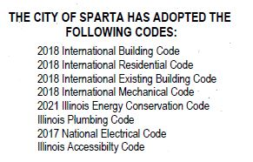
Apply for a building permit
To get a building permit for most construction projects, Code Enforcement needs to review your plans and application. This process applies to building, shed, deck, pool, sign, and demolition permit applications. All work will have to be inspected to ensure compliance with the City’s building codes.
Getting approval for a construction project can take time. Before you can get a building permit, you may be required to get planning approvals. This could involve the Zoning Board, Plan Commission, and City Council.
We want to help make your project a success. If you have any questions during the process, call, email, or visit our office. We’re here to help

A building permit is required before:
(A) Constructing or altering (where the alteration could create danger to life or safety, or compromise the structural integrity) any building with more than 100 square feet of floor area;
(B) Constructing any permanent fence more than ten feet in length.
Two sets of complete plans, (one electronic copy) including plot plan, surface water control (drainage) plan if over 10,000 square feet is altered, parking layout, site work plan, general building plans, electrical, plumbing, and mechanical; plans, including all calculations. Construction documents to be prepared by a registered design professional registered with the State of Illinois, shall bear the signature and seal of a registered design professional when such work involves life safety, structural change, or any public building.
The use of the streets for the storage of materials in the process of construction or alteration of a building may be granted where the use does not interfere with traffic or reduce the usable width of the roadway. Any person seeking to make use of a street for the storage of materials during construction operations shall file an application with the City Clerk for a permit,
Keep the construction site tidy. Ensure that debris, dust, loose nails, and stagnant water from excavations and backfilling are not just lying around the site. The construction site must be cleaned daily and remain clutter-free
Set up safeguards One of the ways to ensure safety on site is by placing engineering controls such as barriers, fences, and safeguards. These will help isolate people from hazardous areas
Any activity that removes the vegetative surface cover requires an erosion and sediment control plan.

